The Journey of Geek Goddess (100 Marks)

<https://www.techgig.com/challenge/question/coding-challenge-expert/SGNlNjF2WE9HNWFnTmN5dGVMUGNZK2RaQnVleEsrYisvWU04c0dmQVM1dz0=/1>

The Geek Goddess has gone to a distant planet called Gigaland. She is on a mission to increase her geeky powers. Gigaland consists of mountains and valleys. The mountains can be seen as a straight-line segment with coordinates (**x1, y1)** and (**x2, y2)** such that x1 < x2 and y1 < y2. There are **N** mountains in Gigaland. The first mountain satisfies x1 = 0, and y1 = 0. **The mountains do not intersect with each other**.

The Goddess starts at (0, 0) on the first mountain. Whenever she is on a mountain she keeps climbing up until its end. After reaching the end of the mountain she jumps off from it. If she lands on another mountain she keeps on climbing it too, otherwise she lands into the dark valley and dies there. Each mountain (x1, y1) (x2, y2) should be regarded as containing the point (x1, y1), but not the point (x2, y2) so that Goddess will land on the mountain if she falls on it from above at a position with x = x1, but she will not land on the mountain if she falls on it from above at x = x2.

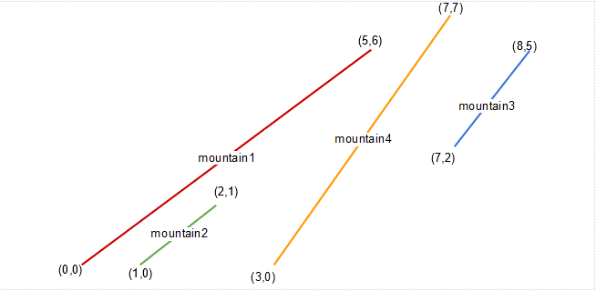

*Image for sample input 1  (not according to scale)*

For every distinct mountain our Goddess climbs, she gets one geeky weapon.

Please count the total number of weapons the Goddess collects before falling into the valley. Note that she will always fall into the valley because there is no more mountains after the **Nth** mountain.

**Input Format**

The first line contains an integer N, the number of mountains in Gigaland.

Next N lines contains 4 integers each : x1, y1, x2, y2 - the coordinates of the line defining the corresponding mountain.

**Constraints**

1 <= N <= 100, 000

0 <= x1, y1, x2, y2 <= 1000, 000, 000

**Output Format**

Return an integer which is the answer to the problem.

**Sample TestCase 1**

Input

4

0 0 5 6

1 0 2 1

7 2 8 5

3 0 7 7

Output

3

Explanation

The scenario is shown in the figure above. The Geek Goddess moves as follows: mountain 1 ---> mountain 4 → mountain 3. Hence, she receives a total of 3 weapons.